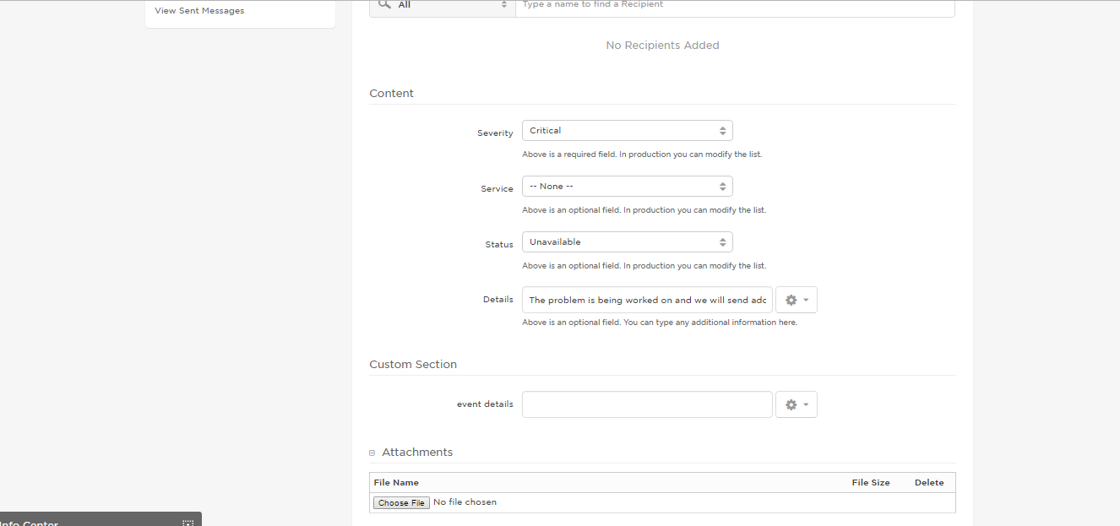

Json payload

--------------------

event creation :

{ "status": "active", "username": "harish.eidiko", "eventIdentifier": 1734172, "date": "17-01-24 07:10:24.597", "eventProperties": [ { "event details": "IT communications Plan" }, { "Details": "The problem is being worked on and we will send additional updates shortly." }, { "Severity": "Critical" }, { "Service": "Email Server" }, { "Status": "Under Maintenance" } ] }

Device Delivery :

{ "recipient": "kpradeep.eidiko", "device": "Work Email", "deliveryStatus": "Delivered", "deviceId": 228801, "eventType": null, "message": null, "eventIdentifier": 1734172, "date": "17-01-24 07:10:29.976", "eventProperties": [ { "event details": "IT communications Plan" }, { "Details": "The problem is being worked on and we will send additional updates shortly." }, { "Severity": "Critical" }, { "Service": "Email Server" }, { "Status": "Under Maintenance" } ] }